SMART LOCK SYSTEM

Name :- Manan Patel  
 D*ept. name of organization :- CHARUSAT UNIVERSITY*   
 City, Country :- Ahmedabad, INDIA

Email address :- [20it100@charusat.edu.in](mailto:20it100@charusat.edu.in)

Email address :- [20it097@charusat.edu.in](mailto:20it097@charusat.edu.in)

Name :- Jay Patel  
 D*ept. name of organization :- CHARUSAT UNIVERSITY*   
 City, Country :- Ahmedabad, INDIA

* *Abstract :-* Auto accidents are the leading cause of death for teens ages 14 to 17. When teen drivers ride with other passengers, their risk of being in a fatal car crash doubles. So to overcome this problems we have designed a smart lock system which would prevent teenagers from driving a vehicle . This lock system basically consists of a microcontroller, radio-frequency identification sensor, radio-frequency identification tags and lock. This lock can be the central lock used in cars or the lock used in motor-cycle.

# Introduction

To solve the problem of underage driving and the security of the vehicle, we have designed a very smart lock system This lock system basically consists of a microcontroller, radio-frequency identification sensor, radio-frequency identification tags and lock. This lock can be the central lock used in cars or the lock used in motor-cycle. When this whole circuit is connected to power source like the battery of a car or motorcycle. When the key (RFID Tags) comes in contact with the RFID sensor the lock opens if the key is correct and beep sound comes from the buzzer if the key is incorrect.

# Ease of Use

### How it will help

So, basically a smart lock which can prevent underage teenagers to drive a vehicle they shouldn’t. It would prevent the accidents occurring most frequently.

Reports says that –

Overall, teenagers underestimate or are unable to recognize hazardous driving conditions. 4.4 percent of 17-year-old drivers and 4.7 percent of 18-year-old drivers were involved in crashes – the highest percentages of any other age group Also Delhi Police data shows that, in the last 10 years (between 2011 and 2020), a total of 307,000 vehicles were stolen in the Capital. This number is more than the number of registered vehicles in all of Srinagar on March 31, 2017 (according to a report mentioned in the road transport year book 2016-17 of the ministry of road transport and highways). Delhi Police officers say that vehicle thefts constitute about 14% of all the crimes in the city. Even during the first hard lockdown, which restricted the movement of people, about 83 vehicles (more than three an hour) were stolen every day in Delhi between March 15 and 30, 2020 and much more.

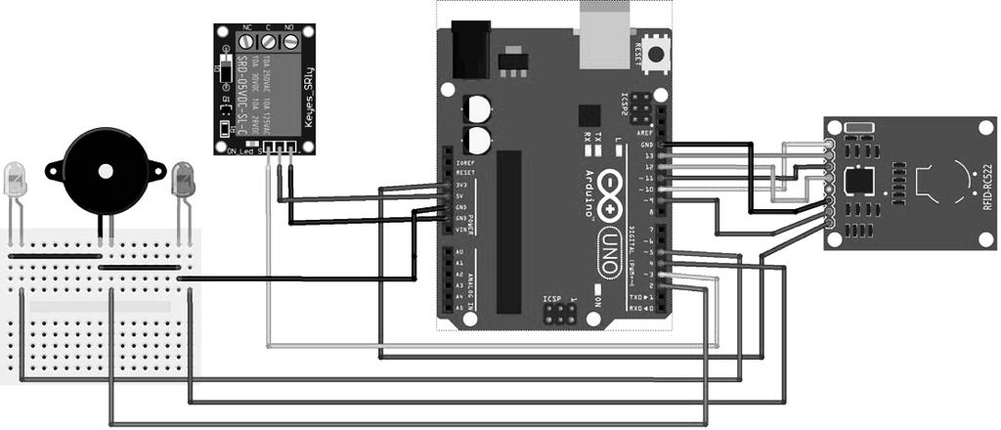

III Tools and Technology

1. Arduino Uno circuit.
2. RIFD Sensor.
3. RIFD Tags/Card.
4. Relay Board.
5. Solenoid Lock.
6. Jumper cables.
7. 9-12 Volt Battery.

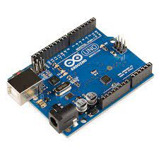

Arduino Uno Circuit.

* Arduino Uno is a microcontroller board.
* It has 14V digital input, 6 analog inputs, a USB connection, a power jack, and a reset button.
* It contains everything needed to support the microcontroller; simply connect it to a computer with a USB cable or power it with a AC-to-DC adapter or battery to get started.

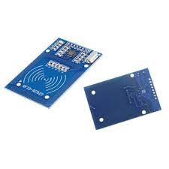RIFD Sensor.

* An RFID Sensor (Radio Frequency Identification Reader) is a device used to gather information from an RFID tag, which is used to track individual objects.
* It is a wireless identification technology that uses radio waves to transfer data from the card tag to an RFID reader and identify the object presence.
* Just like the bar code technology, RFID is used to identify objects, persons, by reading the card tag.

RIFD Tags/Card.

* 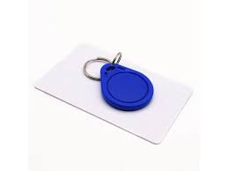RFID tags are a type of tracking system that uses smart barcodes in order to identify items.
* These radio waves transmit data from the tag to a reader, which then transmits the information to an RFID computer program.

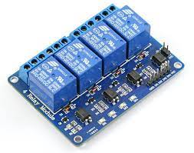

Relay Board.

* Relay boards are computer boards with an array of relays and switches. They have input and output terminals and are designed to control the voltage supply.
* Relay boards provide independently programmable, real-time control for each of several onboard relay channels.

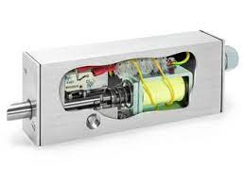

Solenoid Lock.

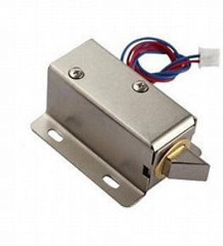

* A lock solenoid is a type of electric locking mechanism that uses an electromagnetic device containing a tightly wound coil of metal wire called a solenoid to provide the mechanical energy that opens and closes the lock.

References:

1. <https://www.homemade-circuits.com/gsm-car-ignition-and-central-lock-using/>
2. <https://create.arduino.cc/projecthub/muhammad-aqib/arduino-rfid-projects-ea3a3b>
3. <https://www.abr.com/what-is-rfid-how-does-rfid-work/>
4. <https://circuitdigest.com/microcontroller-projects/arduino-rfid-door-lock-code/#:~:text=Working%20of%20Arduino%20Based%20RFID%20Door%20Lock%20The,transmitting%20the%20data%20to%20the%20RFID%20Reader%20module>.